Hybrid Peer-to-Peer (Hybrid P2P) System
# Source: Chatgpt (GPT-5-Mini) at [1/16/2026]
A Hybrid P2P system is a type of Peer-to-Peer distributed system that combines centralized and decentralized approaches.
- A central server is used for coordination, indexing, or peer discovery
- Actual data transfer happens directly between peers

Definition
# Source: Chatgpt (GPT-5-Mini) at [1/16/2026]
In a Hybrid P2P system:
- Peers are still equal in sharing data
- A central server helps peers find each other
- The system is partially centralized

Architecture Diagram
# Source: Chatgpt (GPT-5-Mini) at [1/16/2026]
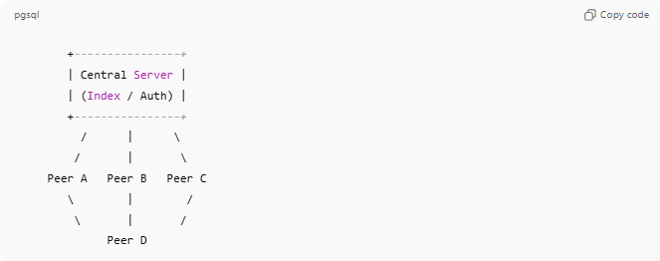
+----------------+
| Central Server |
| (Index / Auth) |
+----------------+
/ | \
/ | \
Peer A Peer B Peer C
\ | /
\ | /
Peer D

How Hybrid P2P Works
# Source: Chatgpt (GPT-5-Mini) at [1/16/2026]
- A peer connects to the central server
- Server provides information about other peers
- Peers communicate directly with each other to exchange data
- Server is not involved in data transfer

Key Characteristics
# Source: Chatgpt (GPT-5-Mini) at [1/16/2026]

Feature | Description
Partial centralization | Central server for lookup
Direct peer communication | Data flows peer-to-peer
Better performance | Faster search than pure P2P
Scalable | Workload shared among peers

Real-World Examples
# Source: Chatgpt (GPT-5-Mini) at [1/16/2026]
- BitTorrent (trackers for peer discovery)
- Skype (early versions used supernodes)
- Napster (file index server)
- Spotify (early versions for music sharing)

Advantages
# Source: Chatgpt (GPT-5-Mini) at [1/16/2026]
- Faster and more efficient peer discovery
- Reduced network traffic compared to pure P2P
- Easier to manage and control

Disadvantages
# Source: Chatgpt (GPT-5-Mini) at [1/16/2026]
- Central server can be a single point of failure
- Less decentralized than pure P2P
- Potential privacy concerns

Hybrid P2P vs Pure P2P
# Source: Chatgpt (GPT-5-Mini) at [1/16/2026]

Hybrid P2P | Pure P2P
Uses central server | No central server
Easier search | Harder search
Faster performance | Slower lookup
Partially decentralized | Fully decentralized

Simple Analogy
# Source: Chatgpt (GPT-5-Mini) at [1/16/2026]
- Hybrid P2P: A phone directory helps you find people, but conversations are direct
- Pure P2P: You must personally know everyone to communicate

